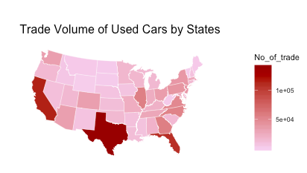

Figure x. Trade Volume of Used Cars by States

Top three states in trade volume of used cars: California, Texas, and Florida.

What factors account for the geographical difference?

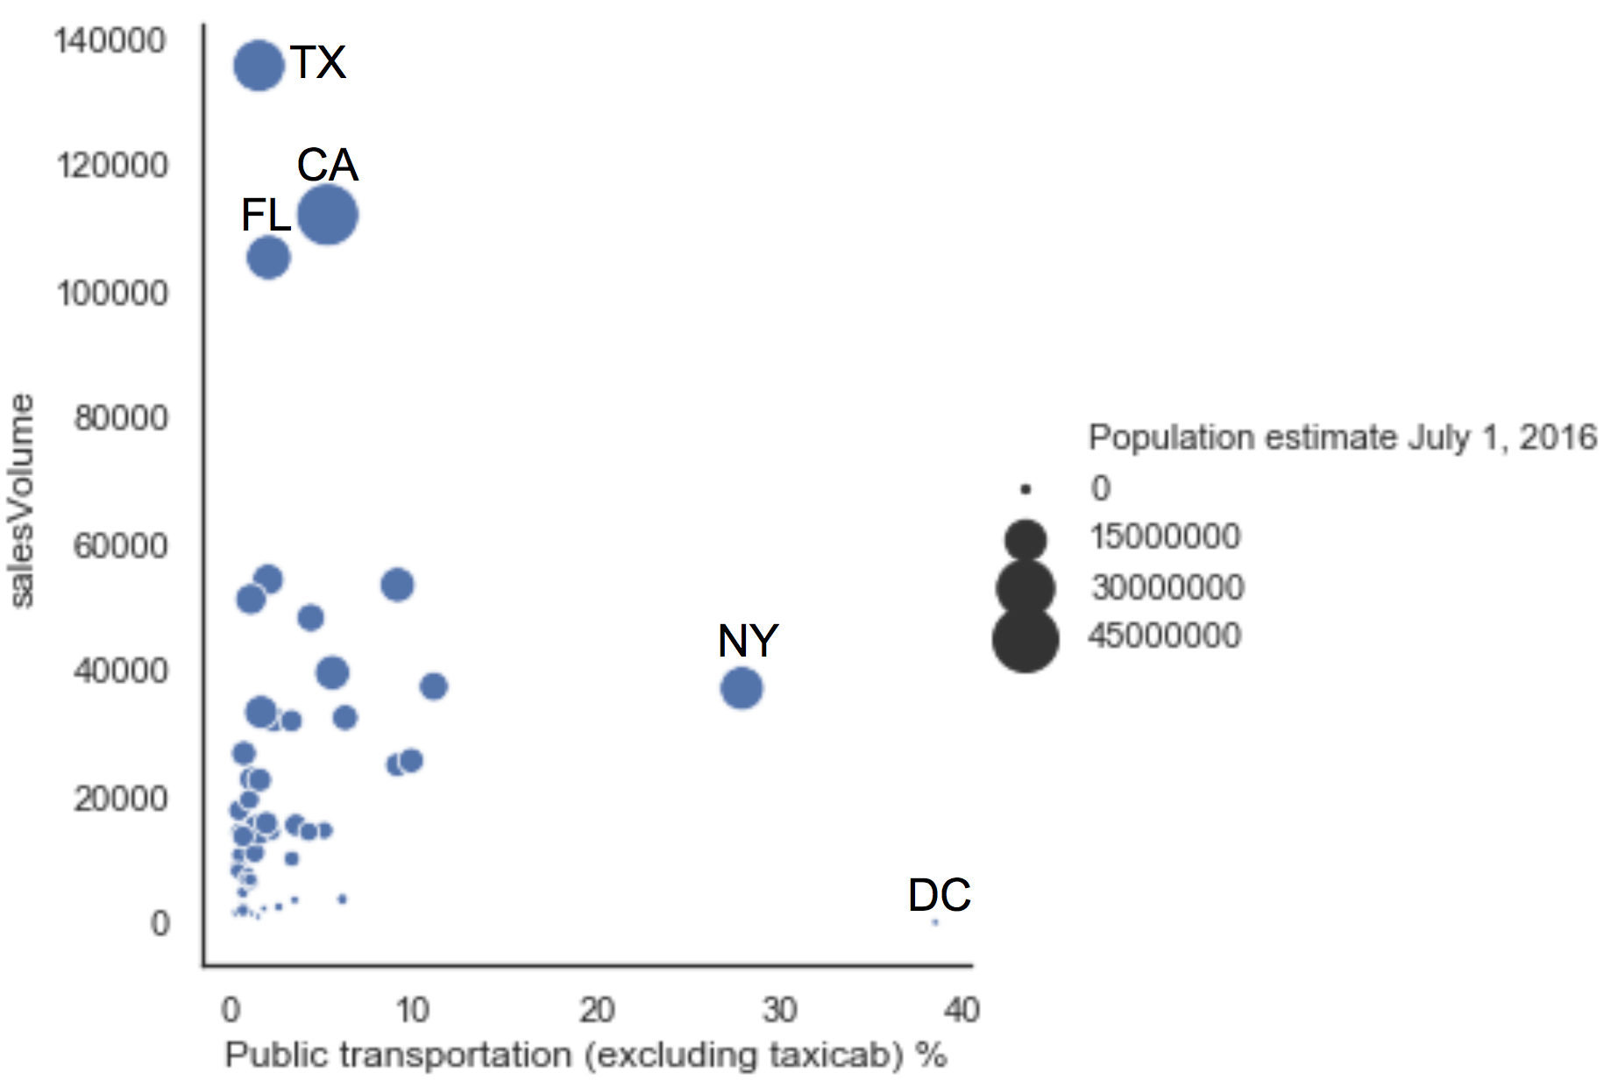

Figure x. Bubble Chart: Sales Volume vs Population vs Public Transportation Usage

The vertical axis indicates the sales volume. The horizontal axis indicates the percentage of workers who use public transportation to commute in a particular state. The size of the bubble indicates the population of that state.

Does greater state population indicate a higher sales volume?

Yes.

Imagining drawing vertical lines on the plot, one pattern is clear: In states with greater population, the sales volume of used cars is greater.

Do states with greater public transportation usage tend to have higher sales volume?

No.

Drawing horizontal lines along the vertical axis, we can see that public transportation usage can barely explain the variability in sales volumes across states, which is slightly surprising.

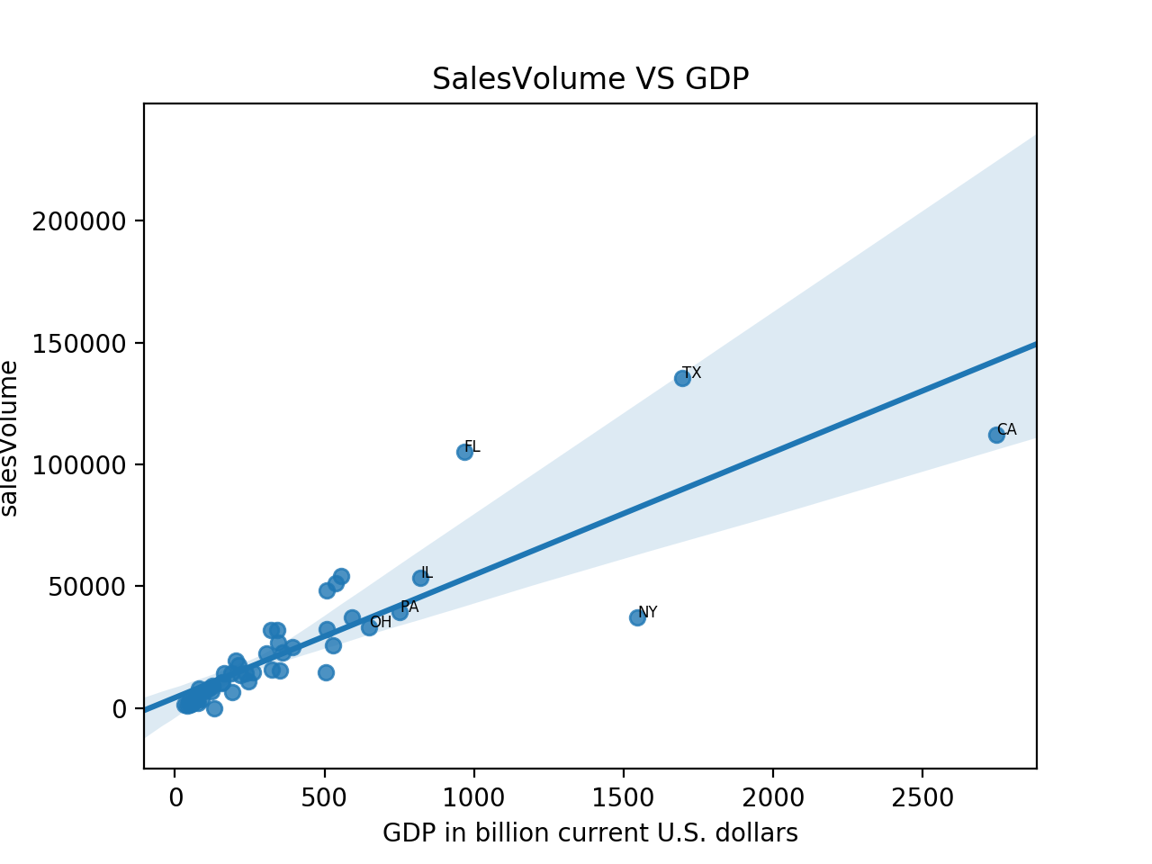

Figure x. Linear Regression Scatter Plot: Sales Volume vs GDP

States with a greater gross domestic product tend to have higher sales volume of used cars. The p-value for the regression is less than 0.000, and R-Squared is 0.74, which means that state GDP can predict 74% of the sales volume in that state.

Also, note that GDP is positively related to population. No wonder that GDP can largely explain the sales volume since we've seen in Figure 8 that greater state population indicates a higher sales volume.